**ANGULAR PROJECT   
E-COMMERCE WEBSITE – SHOPPING CART**

STEP 1: COMPONENTS CREATION:

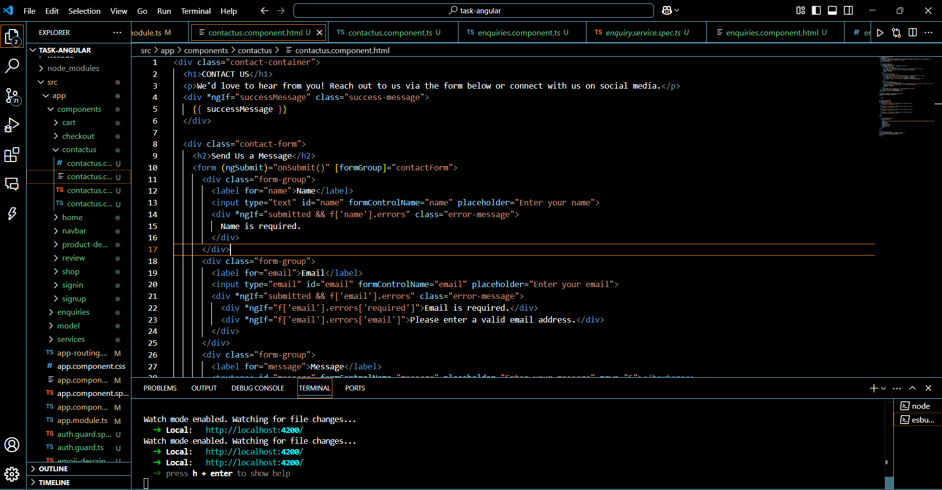

STEP 2: API CREATION (JSON FILE)

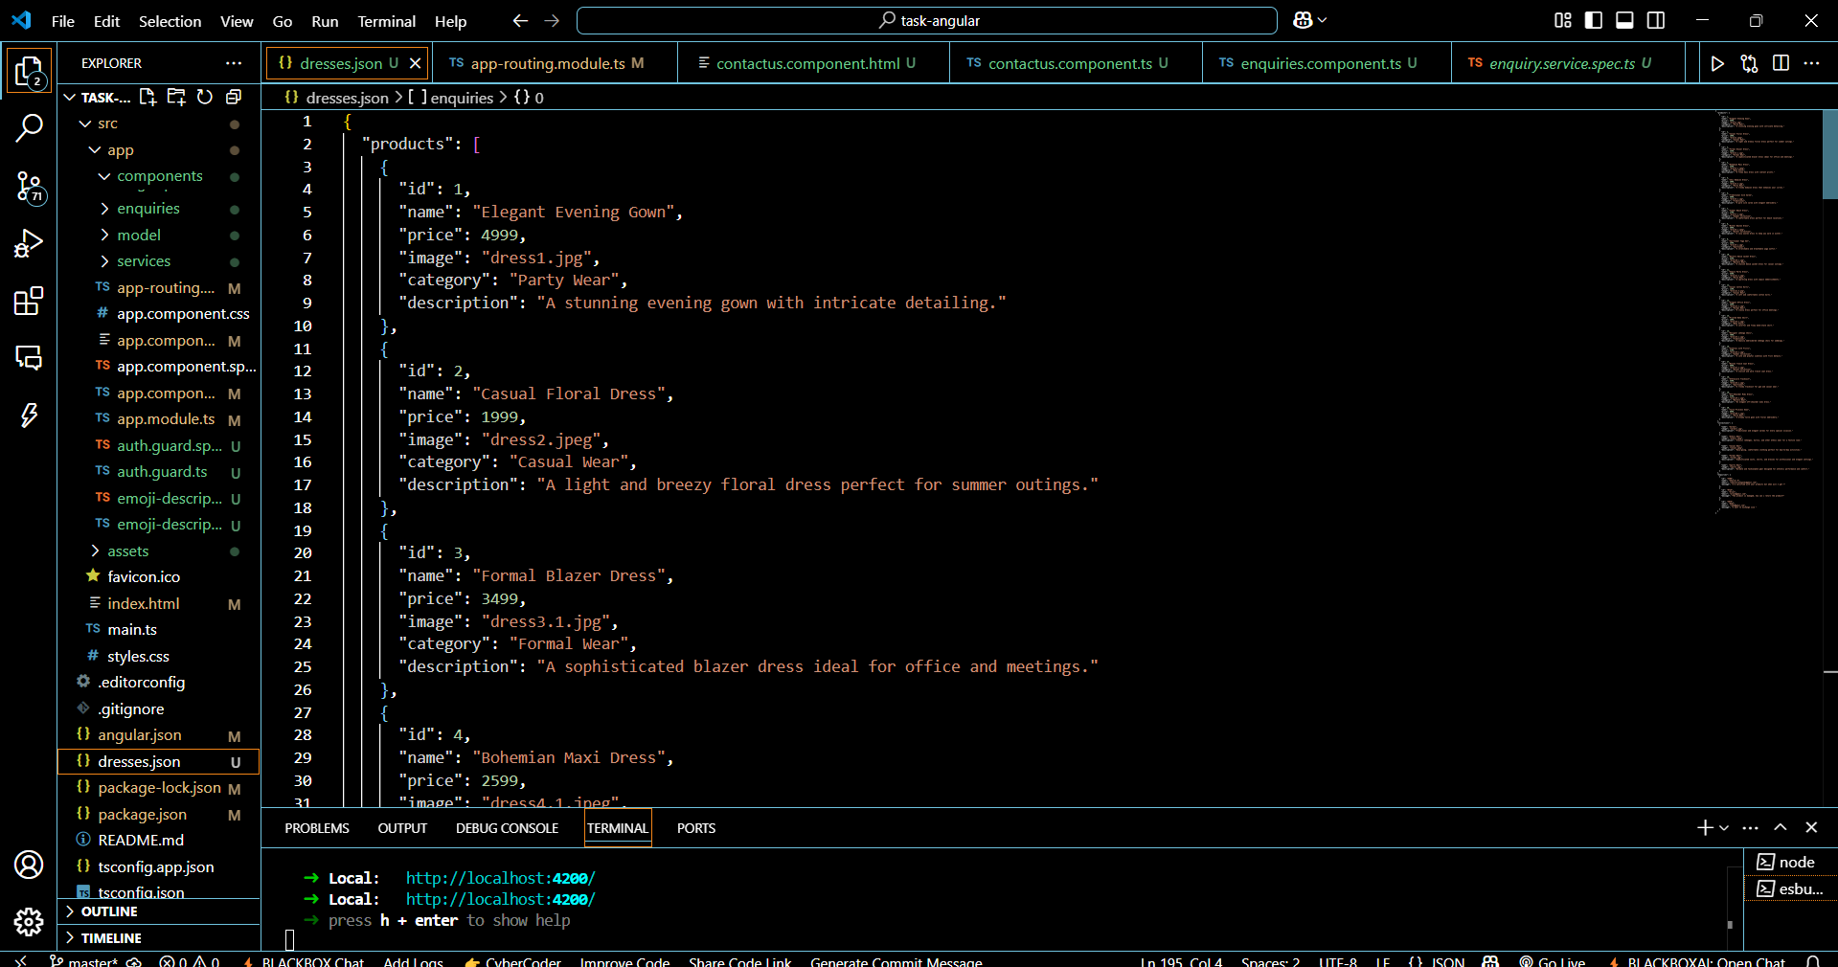

STEP 3: AUTH GUARD

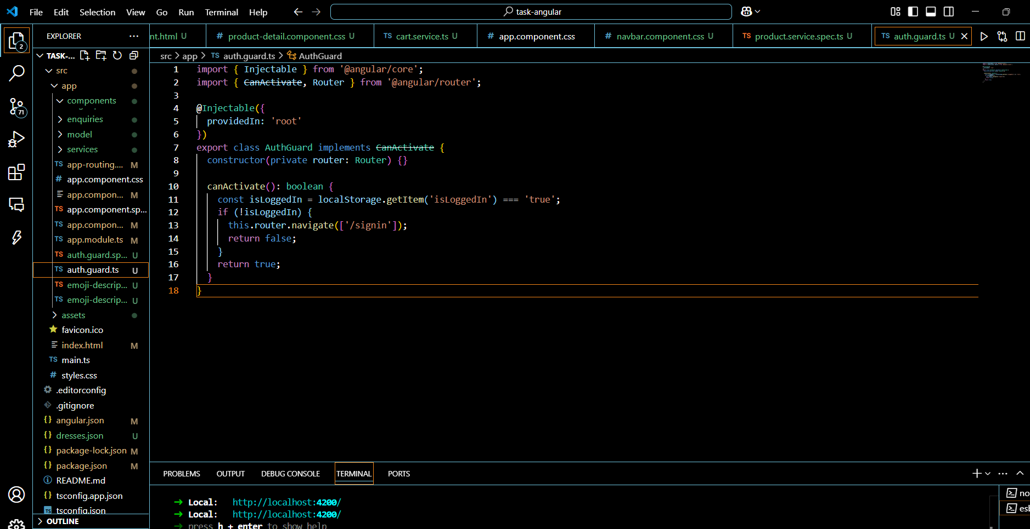

STEP 4: PIPES

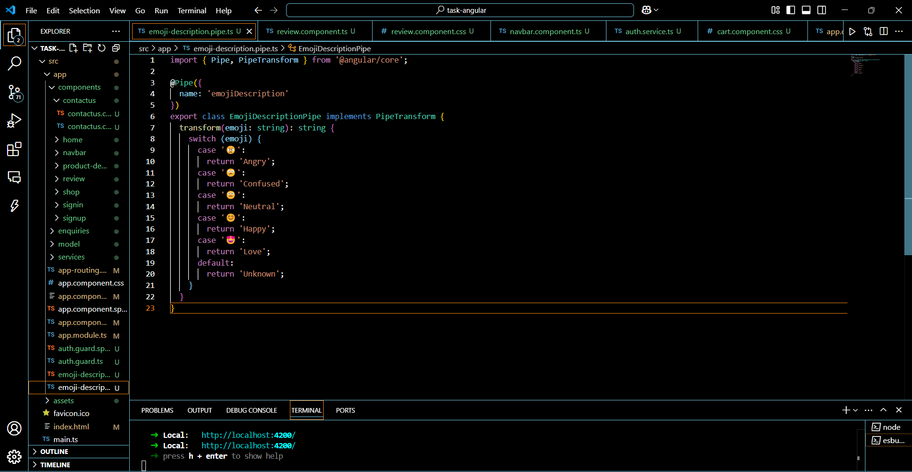

**OUTPUT:**

**HOME**

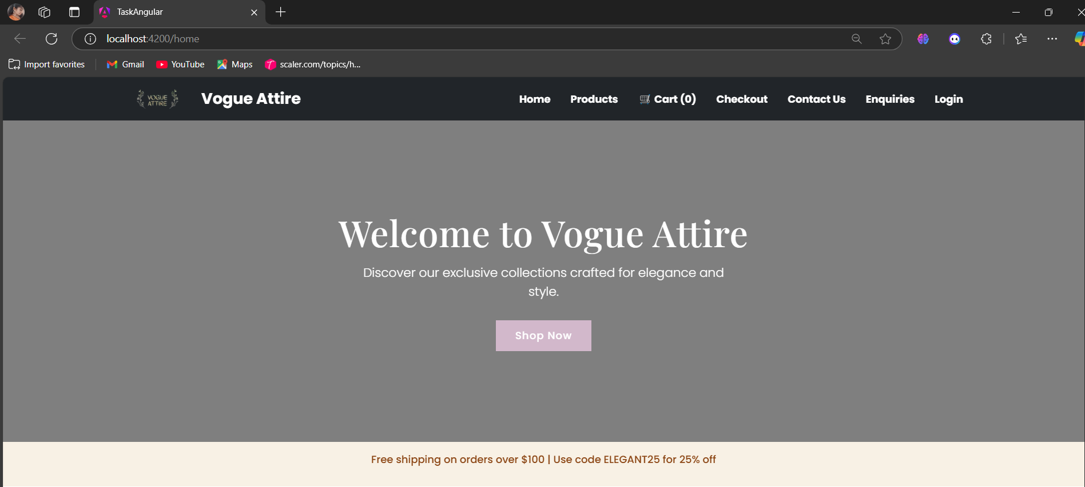

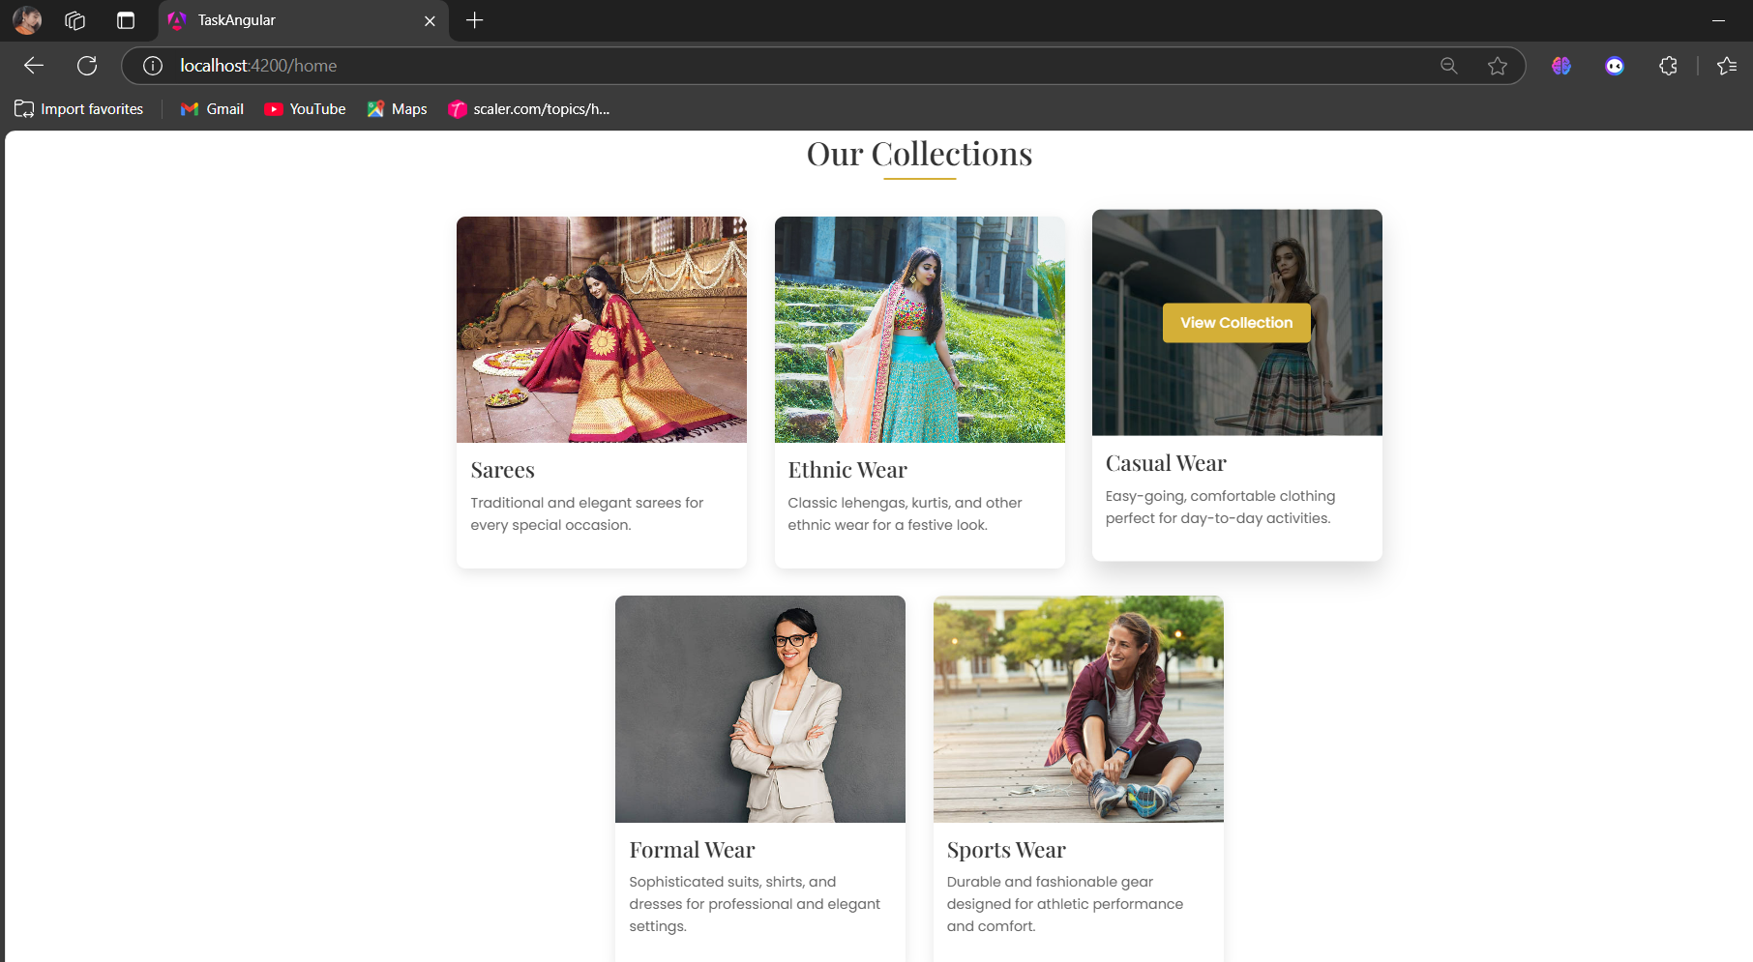

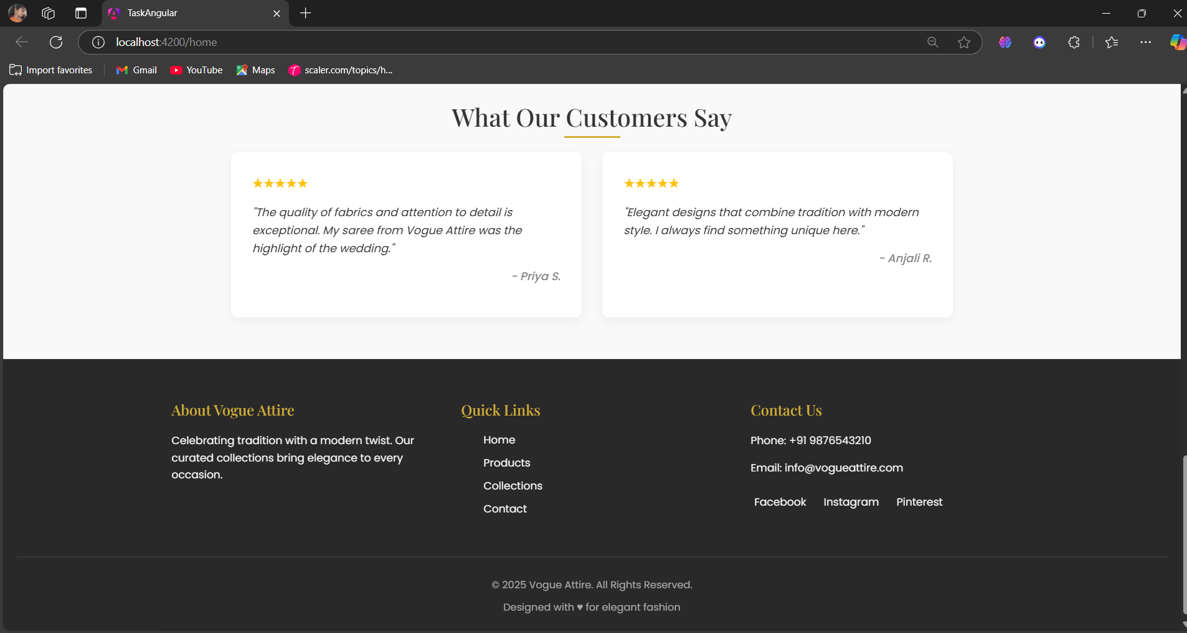

**PRODUCTS**

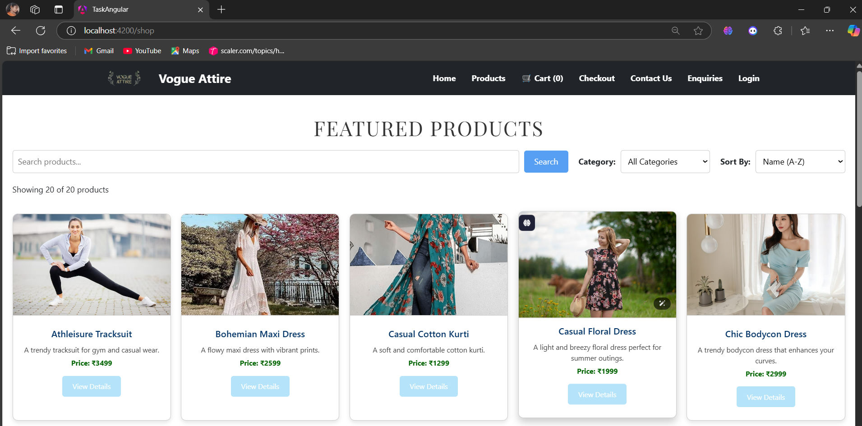

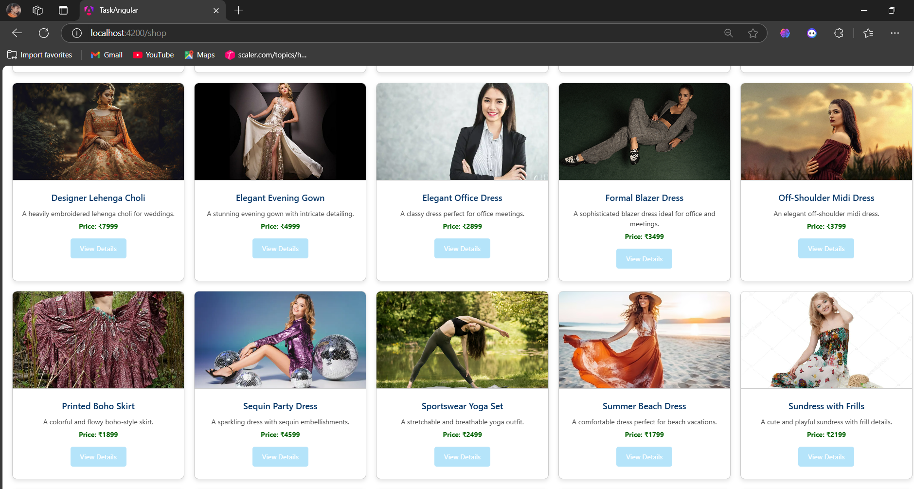

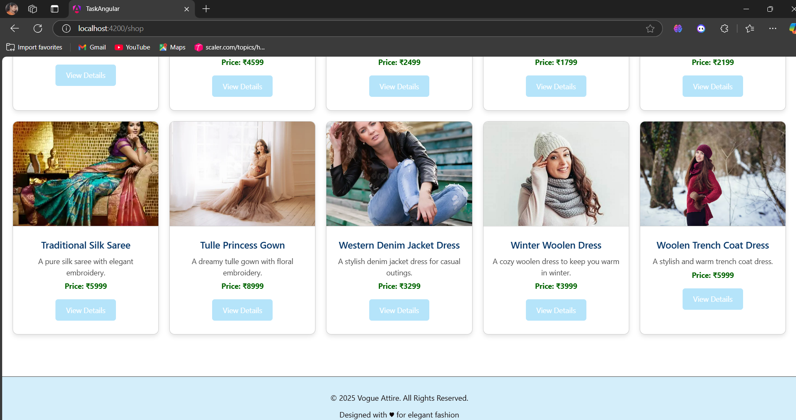

* We can filter the products by category or we can sort them and also, we can search the product we want:

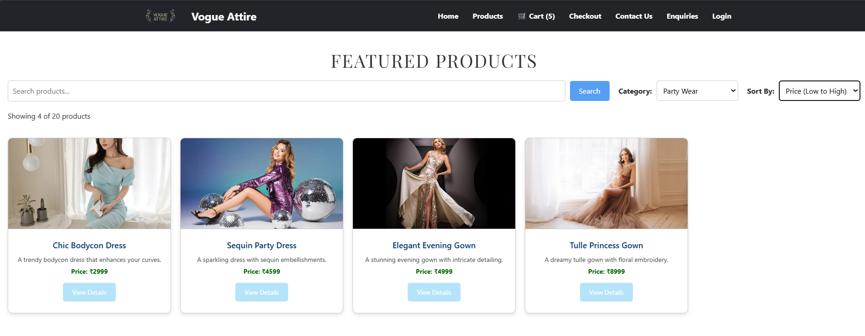

* When we click on view details 🡪Product details

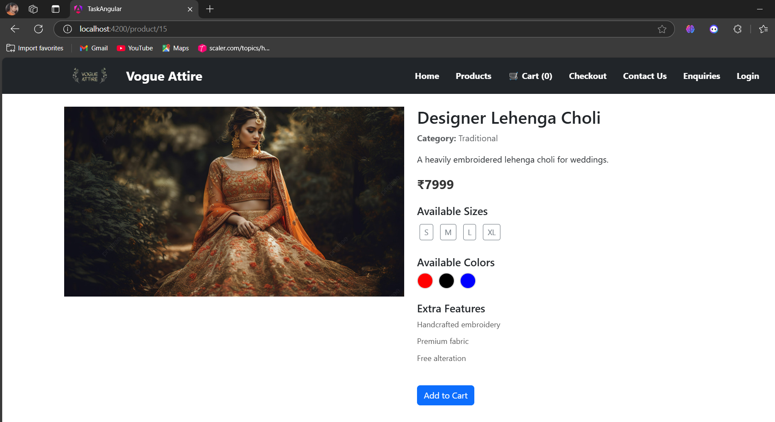

* To add an item to the cart, selecting both size and colour is required. otherwise, a warning will be displayed.

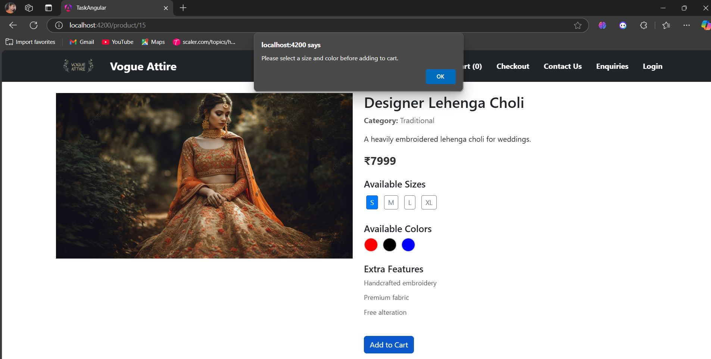

* Adding an item to the cart:

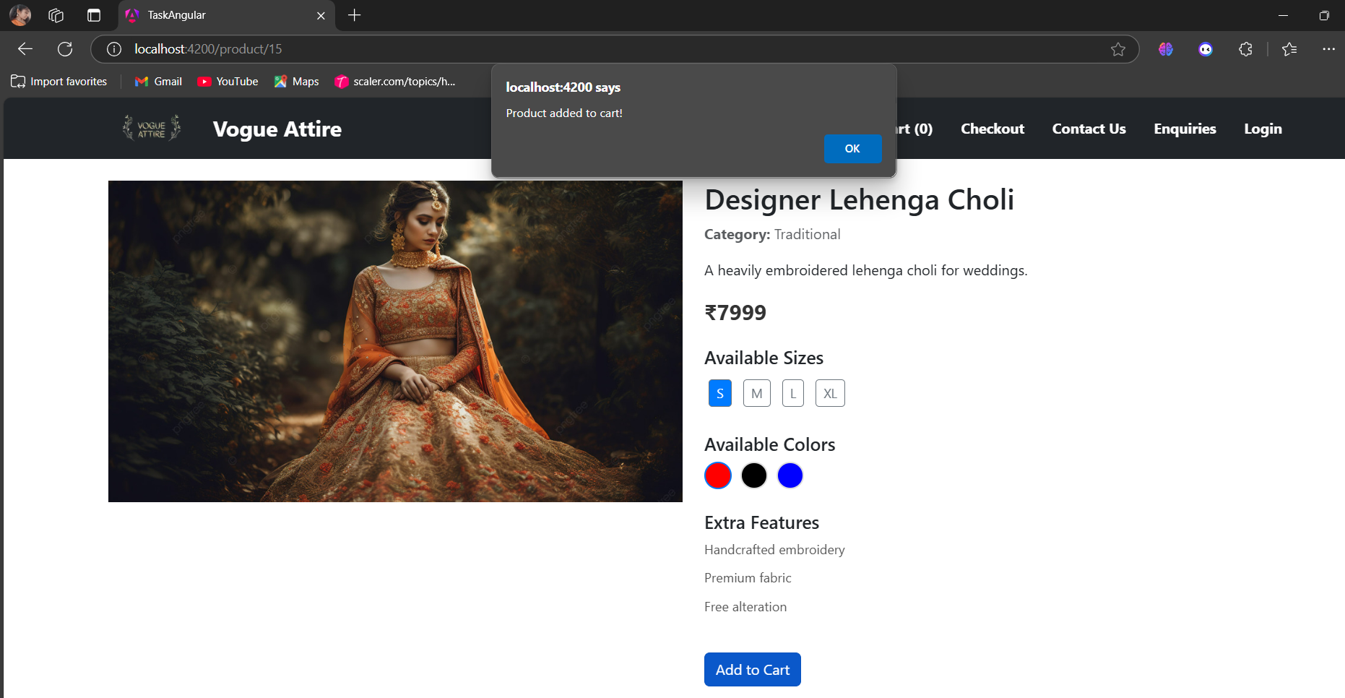

**CART PAGE**

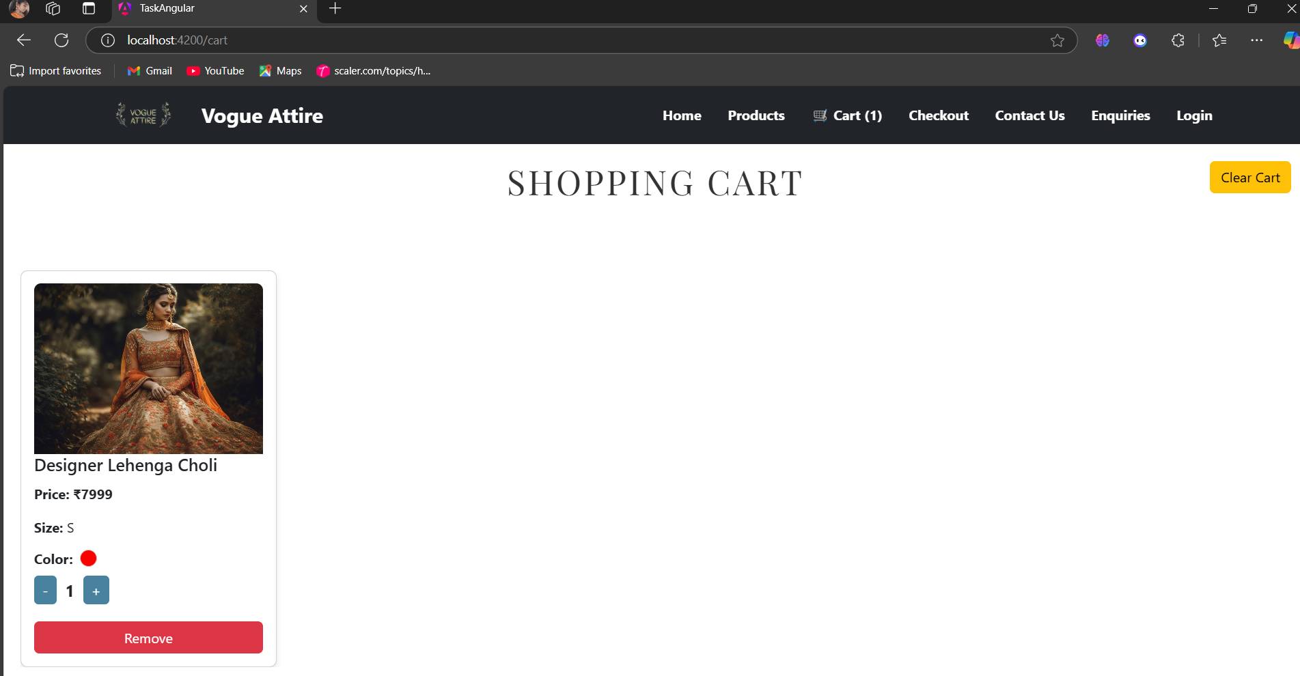

* The quantity of products can be increased, and products can also be removed from the cart.

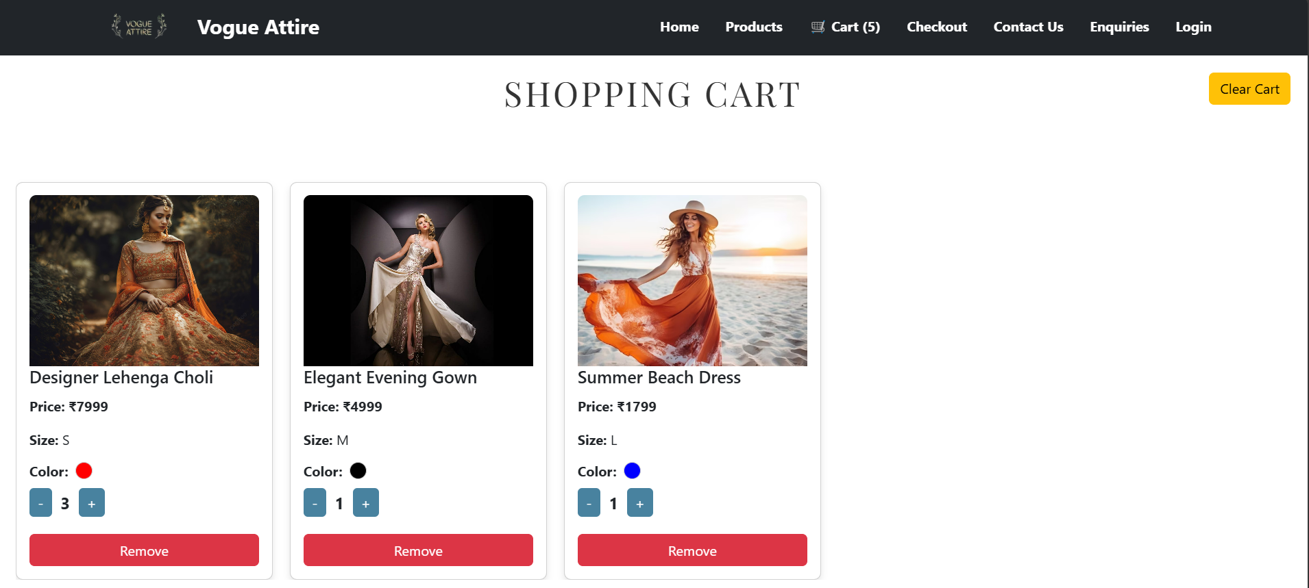

**CHECKOUT PAGE**

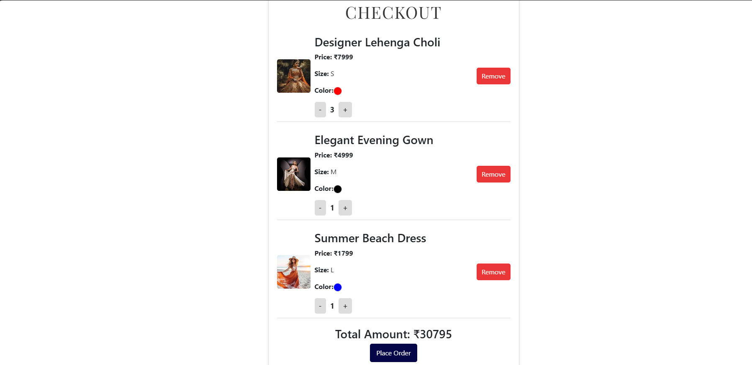

* The products can also be removed before placing order by remove button.

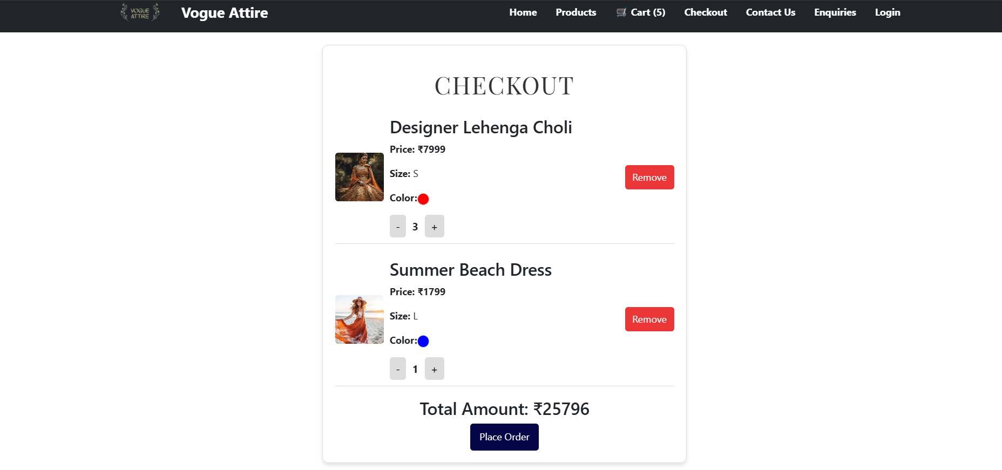

* When we click on Place order:

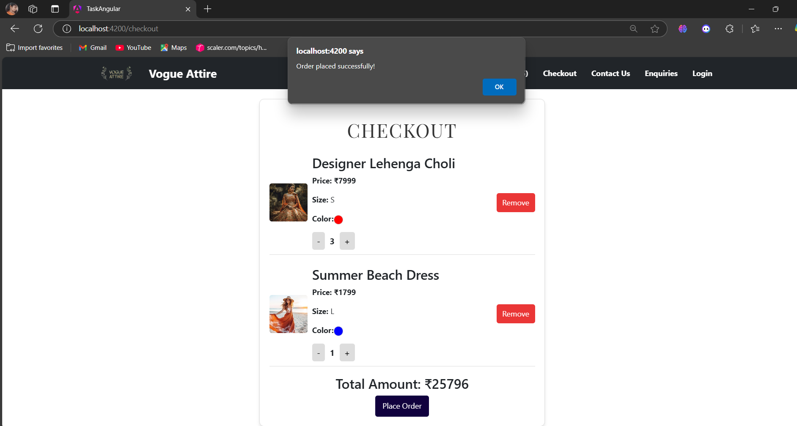

* When we click ok 🡪 the order gets placed and the cart gets cleared.

**CONTACT US**

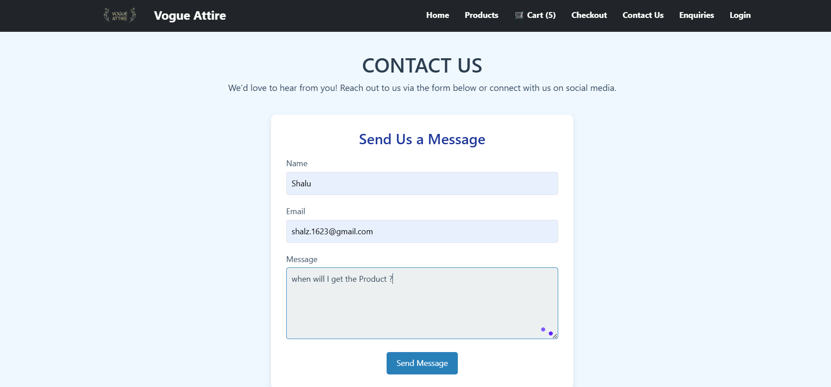

* When we click on send message 🡪 The messages will be sent and gets stored in the enquiry page.

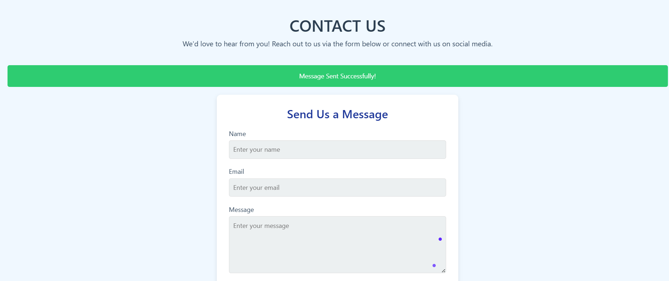

**ENQUIRIES**

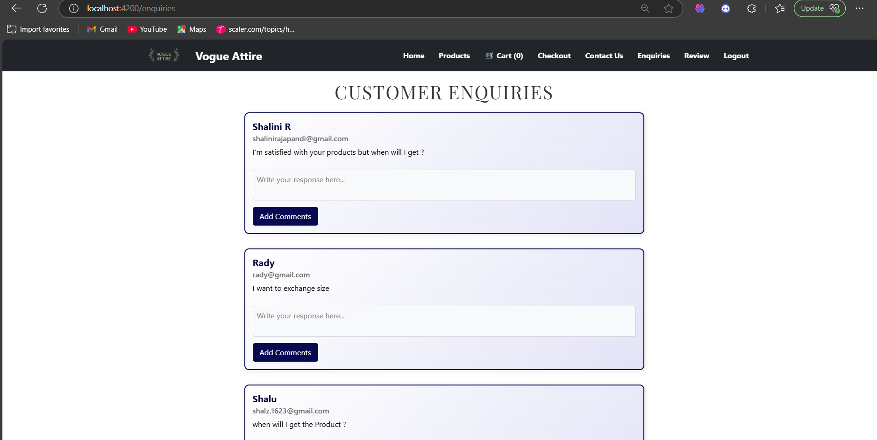

* Other customers can also add comments to the queries.

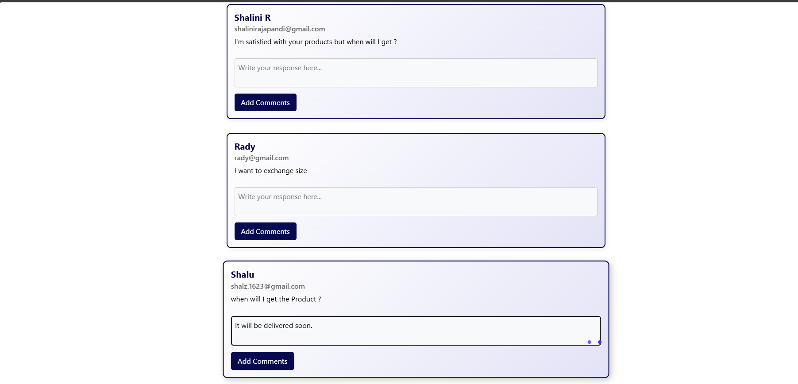

* The comments will be shown to all the customers.

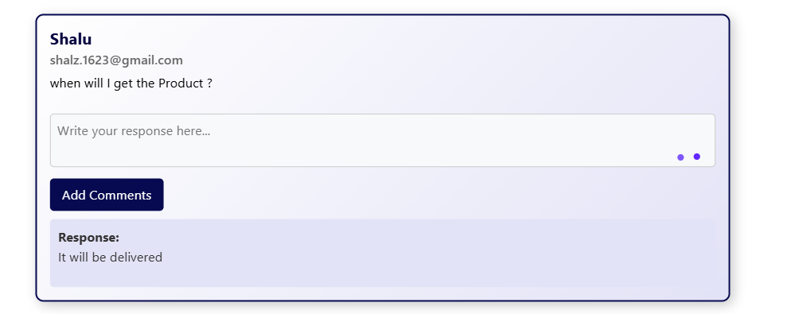

**REVIEW**

* The review page can only be viewed by logged-in users.

**LOGIN:**

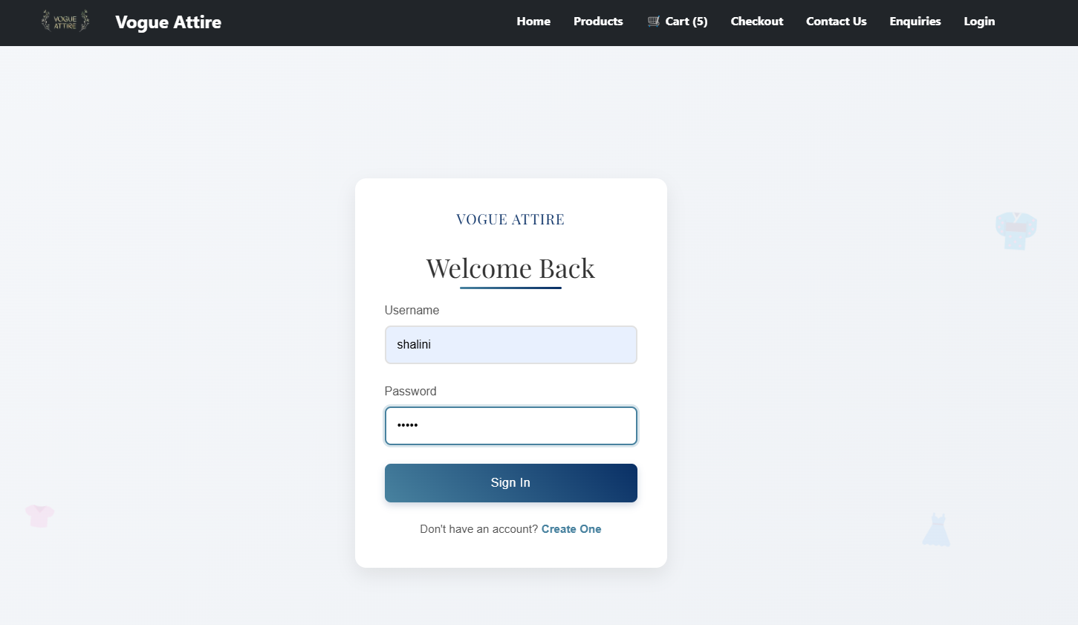

* If we don’t have an account, we can create one using signup.

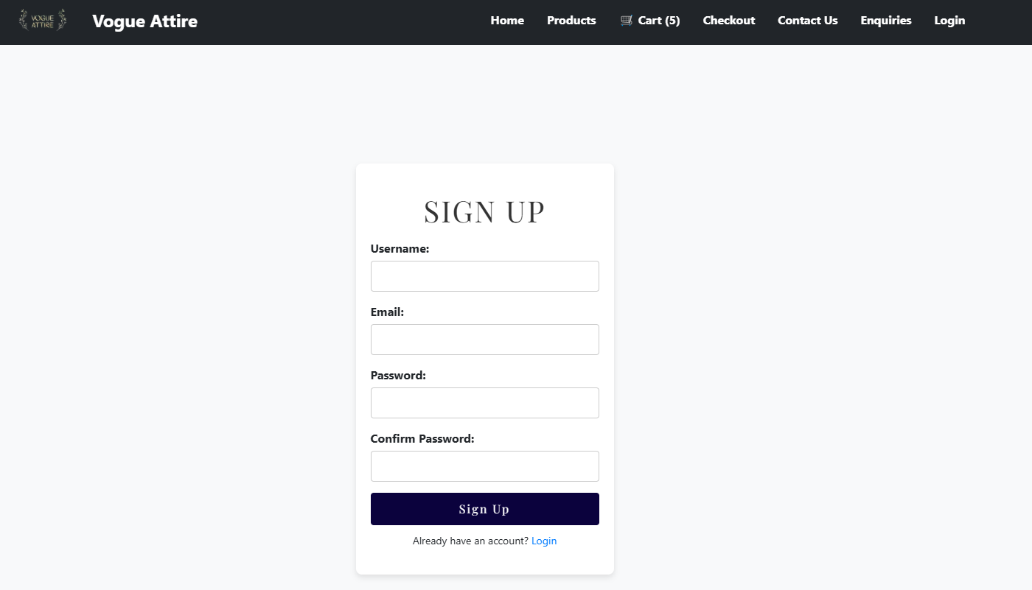

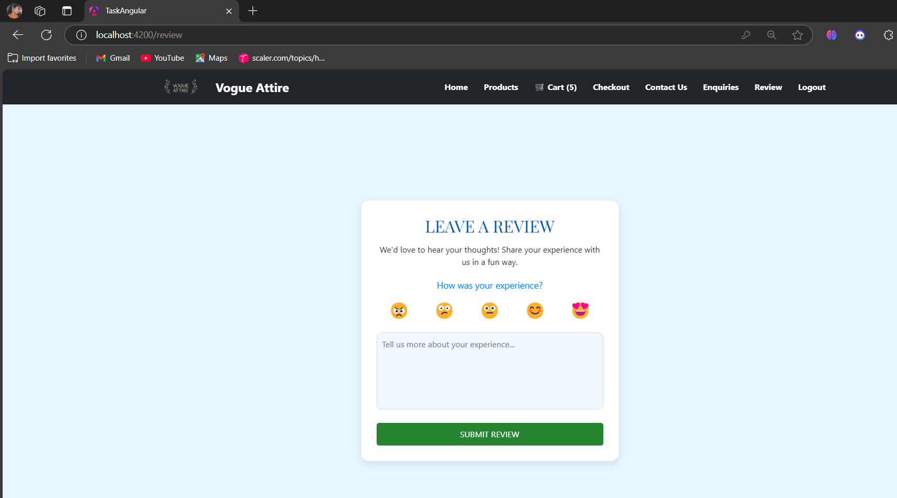

* We need to choose emoji and need to give review otherwise show warning.

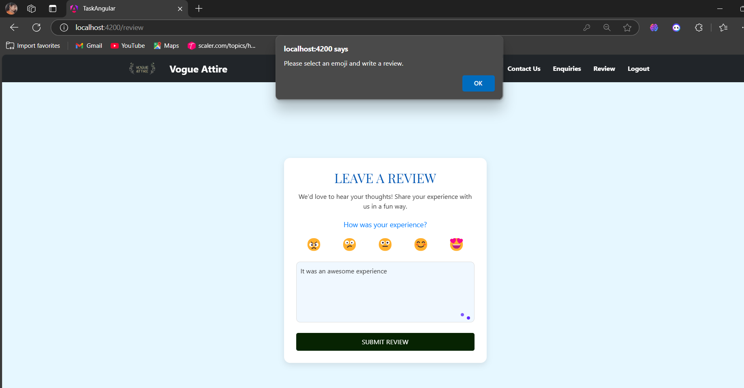

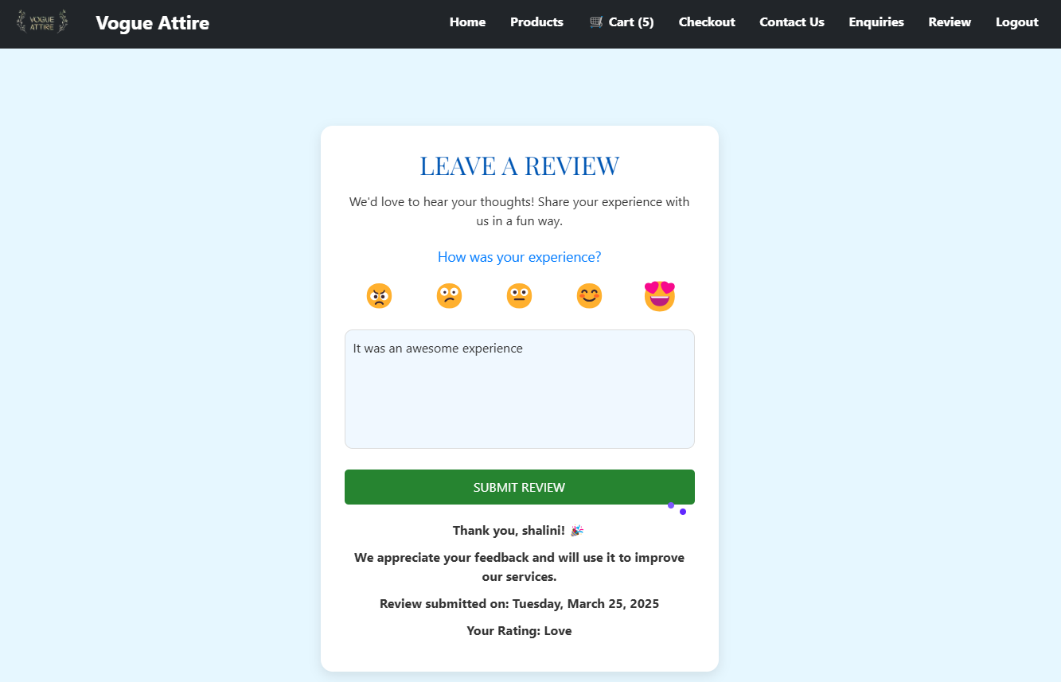

**CONCLUSION**

* Angular Shopping Cart is a Single Page Application (SPA) built using Angular to provide a seamless online shopping experience. It includes essential e-commerce features such as browsing products, viewing detailed product descriptions, selecting size and color options, making inquiries, leaving reviews, and managing authentication. The application utilizes Angular Pipes for data formatting and filtering, making product searches more efficient. The Auth Guard feature ensures that only authenticated users can access certain sections, such as the review system and inquiry forms.
* The Home Page displays featured products and quick navigation links, while the Products Page lists all available items with sorting and filtering options. The Product Detail Page showcases detailed information along with an enquiry form for customer queries. Users can submit reviews, and a custom pipe formats review dates for better readability. The Contact Us page provides a way to reach customer support, ensuring seamless communication. The app uses Services with Observables to fetch product and review data dynamically. Future enhancements could include a shopping cart, a checkout system, and real-time database integration for a more comprehensive e-commerce experience.